|  |  |  |  |  |  |  |  |
| --- | --- | --- | --- | --- | --- | --- | --- |
| **A** | **B** | **C** | **A’** | **(A’. B)’** | **(A’. B)’+C** | **((A’. B)’+C)’** | **RESULT** |
| 0 | 0 | 0 | 1 | 1 | 1 | 0 | 0 |
| 0 | 0 | 1 | 1 | 1 | 1 | 0 | 0 |
| 0 | 1 | 0 | 1 | 0 | 0 | 1 | 1 |
| 0 | 1 | 1 | 1 | 0 | 1 | 0 | 0 |
| 1 | 0 | 0 | 0 | 1 | 1 | 0 | 0 |
| 1 | 0 | 1 | 0 | 1 | 1 | 0 | 0 |
| 1 | 1 | 0 | 0 | 1 | 1 | 0 | 0 |
| 1 | 1 | 1 | 0 | 1 | 1 | 0 | 0 |

**Question 2B:**

**Question 3 i)**

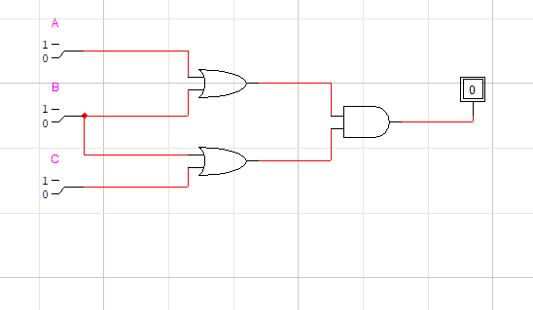

**Question 3 ii)** 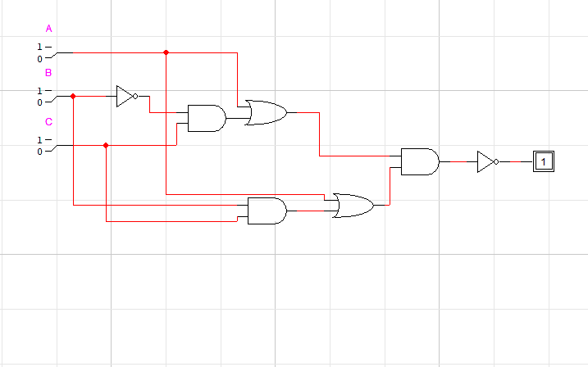

**Question 3 iii)**

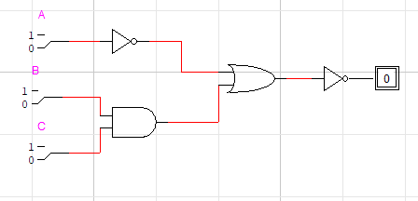

**Question 04(a)**

|  |  |  |  |  |
| --- | --- | --- | --- | --- |
| **A** | **B** | **A’** | **AB** | **A’** **⊕AB** |
| 0 | 0 | 1 | 0 | 1 |
| 0 | 1 | 1 | 0 | 1 |
| 1 | 0 | 0 | 0 | 0 |
| 1 | 1 | 0 | 1 | 1 |

**Question 04(b)**

|  |  |  |  |  |  |
| --- | --- | --- | --- | --- | --- |
| **A** | **B** | **C** | **A’** | **B⊕C** | **A’(B⊕C)** |
| 0 | 0 | 0 | 1 | 0 | 0 |
| 0 | 0 | 1 | 1 | 1 | 1 |
| 0 | 1 | 0 | 1 | 1 | 1 |
| 0 | 1 | 1 | 1 | 1 | 0 |
| 1 | 0 | 0 | 0 | 0 | 0 |
| 1 | 0 | 1 | 0 | 1 | 0 |
| 1 | 1 | 0 | 0 | 1 | 0 |
| 1 | 1 | 1 | 0 | 0 | 0 |

**Question 05**

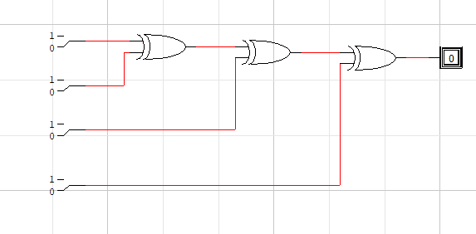

**Even Parity:**

|  |  |  |  |  |
| --- | --- | --- | --- | --- |
| **A** | **B** | **C** | **D** | **X** |
| 1 | 0 | 1 | 0 | 0 |
| 1 | 1 | 0 | 0 | 0 |
| 1 | 0 | 0 | 1 | 0 |

**Odd Parity:**

|  |  |  |  |  |
| --- | --- | --- | --- | --- |
| **A** | **B** | **C** | **D** | **X** |
| 1 | 1 | 1 | 0 | 1 |
| 1 | 1 | 0 | 1 | 1 |
| 1 | 0 | 1 | 1 | 1 |

**Note: The rest of the questions were performed in LAB**